Freelance Content Writer
Job Description Template

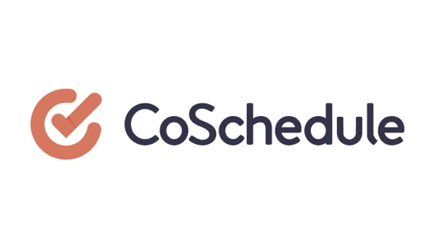
A Free Template From CoSchedule

About Your Company:
What should candidates know about your organization?

Your Audience:
What should candidates know about who they’ll be writing for? Describe your basic audience persona here.

Required Skills:
What skills and competencies will you expect from candidates? Be clear and realistic.

Job Demands:
What should candidates know about the content you expect them to write? Include a paragraph-long description here (with links to relevant examples).

Benefits:
What are the benefits you’ll offer selected candidates?

Bonus Requirements:
What are some skills candidates aren’t required to have, but would be nice to have?

