[Insert Your Logo]

Social Media Policy Template

Why Do We Have A Social Media Policy?

At {Insert Company Name} we think that social media is an important tool both inside and outside the office. To put our best foot forward we created the following social media policy. In this policy, we’ll review:
- Who are we on social media?
- What to post
- What not to post
- Social media work policy
- Enforcement of policy
- Who to contact
- What to do in crisis situation
- What to do about questions and comments about {insert company name}
- How to have great online social media etiquette
- How to identify yourself online

These policies are put into place to not only to help you identify what our guidelines regarding social media in the office are but also to protect you and prevent an unintended social media mistake, that could be costly for both you and the company.

Social Media Voice and Presence
The guiding principles at {Insert Company Name} are what we strive to live by every day. Those principles also apply to both the company social media accounts and your personal accounts.

Here at {Insert Company Name} we want to be known for

1. Having a great product.
Therefore, our social conversations should include information about latest updates, newest features and other
2. {Insert second guiding principle here}
Actionable item: How can they achieve this on social media?
3. {Insert third guiding principle here}
Actionable item: How can they achieve this on social media?
4. {Insert fourth guiding principle here}
Actionable item: How can they achieve this on social media?
5. {Insert fifth guiding principle here}
Actionable item: How can they achieve this on social media?
6. {Insert sixth guiding principle here}
Actionable item: How can they achieve this on social media?

Standards For Social Media Posts
What can you post and what should you avoid? These questions are common when it comes to social media, especially when your employees are posting about your company or have them associated on their social profiles.

What Can We Post About?
These are topics that have been preapproved by the social media team that are ok for you to post about on your personal social media channels! Keep your family updated on what’s going on at work has never been so easy!

1. Upcoming auditions
2.
3.
4.
5.
6.
7.
8.
9.
10.

What Should We Avoid Posting About?
1. Sensitive company information
2.
3.
4.
5.
6.
7.
8
9.
10.

*It is important to note that derogatory language is defined at {insert company name} as anything that degrades, insults, or implies that an individual that belongs to one of those groups is anything less than a human being with their own unique experiences and perspectives. At {insert company name here} we strive to accept and respect all perspectives and people, no matter who they are.

Examples of Social Media Messaging

Example of a social media message we want to avoid:
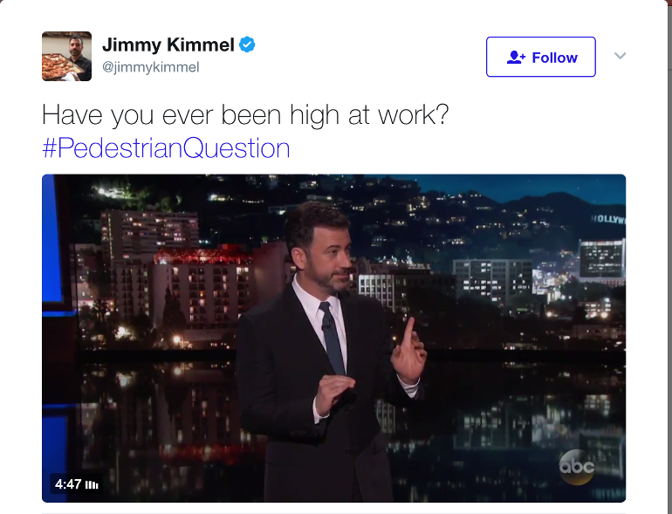

Example of social media message we want to see:

Social Media At Work
The following information about employee social media usage while at the office.

Social Media Networking Sites that are not allowed to be browsed during office hours:
- Facebook
- Twitter
- Instagram
- Snapchat
- Pinterest
- Tumblr
- Google+
- LinkedIn

Exceptions to those Rules:
- If working with social media is part of your job duties
- Social networking sites can be browsed in the breakroom whenever you are off the clock, including lunch times
- If there is an office party or event
- If there is a family emergency and social networks are a way to get a hold of family members.
- {insert

We understand that social media is a part of our daily lives and we don’t want to completely restrict your social media usage. However, we do want to be as productive as we can be during office hours. If you have any questions, please see the contact list in the next section of this policy.

Enforcement Of The Social Media Policy
The following information details the actions that will be taken by {insert company name} and HR if these policies are broken.

Social Media Use in the Office:
If the policy regarding social media use in the office is broken the following steps will be taken.

1. First Offense {insert reprimand here}
2. Second Offense {insert reprimand here}
3. Third Offense {insert reprimand here}
4. Final Offense {insert reprimand here}

Inappropriate Content Shared On Social Channels

1. First Offense {insert reprimand here}
2. Second Offense {insert reprimand here}
3. Third Offense {insert reprimand here}
4. Final Offense {insert reprimand here}

Company Information or Derogatory, or Harassing Content Shared On Social Channels
1. Meeting with Supervisor
2. Meeting with Head of Department
3. Meeting with HR

Who To Contact About Social Media Questions
At {insert company name} we encourage questions all the time. If you have a question regarding a social media message, what information you can share with your followers or even a question on this policy

Social Media Specialist:
Name: Email:
When to contact:

Social Media Manager:
Name: Email:
When to contact:

Marketing Team Manager
Name: Email:
When to contact:

CMO
Name: Email:
When to contact:

How To Deal With A Crisis Situation

Step 1:

Step 2:

Step 3:

Step 4:

Contacts for Crisis Situation
The following people need to be contacted immediately if a crisis arises.

Social Media Manager:
Name: Email:
Phone:

Marketing Team Manager
Name: Email:
Phone:

CEO
Name: Email:
Phone:

Head of PR
Name: Email:
Phone:

Head of HR
Name Email:
Phone:

Managing Your Online Presence

Five Steps To Great Online Etiquette
1.
2.
3.
4.
5.

What To Do About Brand Questions and Complaints
1.
2.
3.

Be Up Front About Who You Work For
1. {Insert disclaimer one}
2. {Insert disclaimer two}

