UX Copy Doc Template

[Project Name]

Last updated: [Date]
Writer: [Name]
Designer: [Name]

Supporting Documents

// A bullet list of additional project documents for further reference

- Project overview
- Brand guide
- Design mockups/design specs
- User research

Project Notes
// List additional instructions for writing: goal of the page, desired action, notes on tone of voice, style, etc.

Images

Add a mockup of how the page or new website element will look.
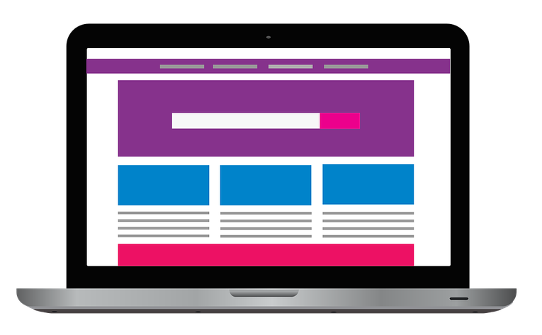

Copy

 | Current Copy | New Copy | Copy Variations
H1
H2
Body
Button

